

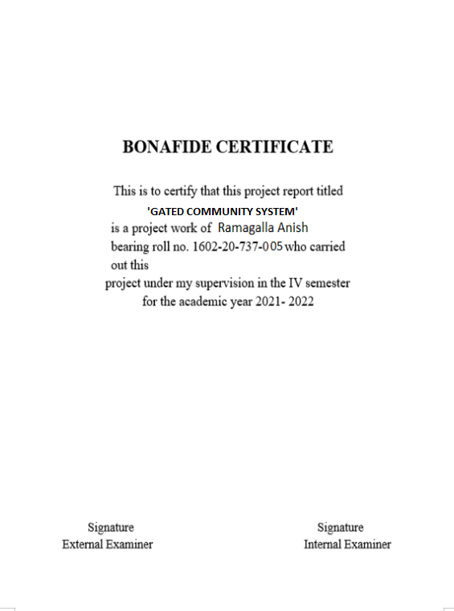

**GATED COMMUNITY DATABASE**

**ASSIGNMENT-1**

**R.ANISH**

**1602-737-005**

**ABSTRACT:**

Gated community database aims to simplify the problems in the gated community. The present system is manual and maintains a written record of the issues and interactions with the community members which is tedious. This automated system provides a convenient way to track and tackle problems faced by the community people like Tracking the water usage per block in the community No of sales and purchasers per block in the community Percentage of parking lot utilized per block.

## Requirement Analysis

List of Tables**:**

* community
* block\_info
* water\_corporation
* parking
* sales
* purchases

## List of Attributes with their Domain Types:

### Community\_details:

* CID NUMBER
* NO\_OF\_BLOCKS NUMBER
* CNAME VARCHAR2(30)
* CADDRESS VARCHAR2(30)

### Block\_info\_:

* CID NUMBER
* BLOCKNAME VARCHAR2(30)
* BLOCK\_ID NUMBER(59)
* NO\_OF\_FLOORS NUMBER

### Water\_corporation:

* BLOCK\_ID NUMBER
* NO\_OF\_LT NUMBER
* AMOUNT\_SPENT NUMBER
* W\_ID NUMBER

### parking:

* BLOCK\_ID NUMBER
* NO\_OF\_ALLOTMENT NUMBER
* PARKING\_ID NUMBER

**Purchases:**

* BLOCK\_ID NUMBER
* P\_ID NUMBER
* NO\_OF\_PURCHASES NUMBER

**Sales:**

* BLOCK\_ID NUMBER
* S\_ID NUMBER
* NO\_OF\_SALES NUMBER

# DESIGN

**Entity Relationship Diagram**

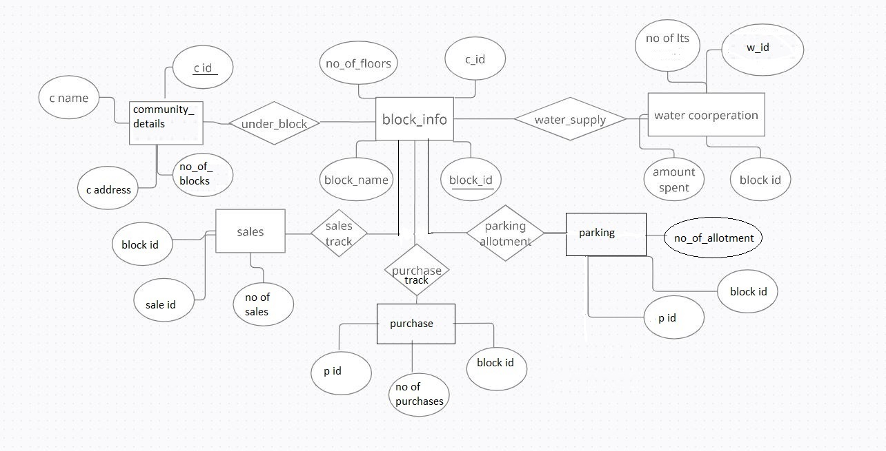

# DDL OPERATIONS

1) create table community\_details(

cid number(10),

c\_name varchar(15),

c\_address varchar(15),

no\_of\_blocks number(20));

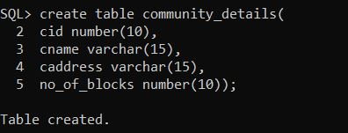

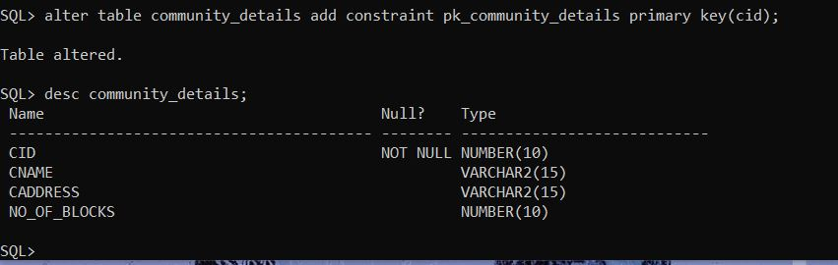

2) create table block\_info\_(

cid number(10),

block\_id number(10) primary key,

block\_name varchar(15),

no\_of\_floors number(10));

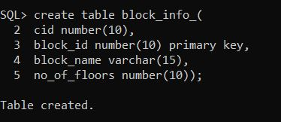

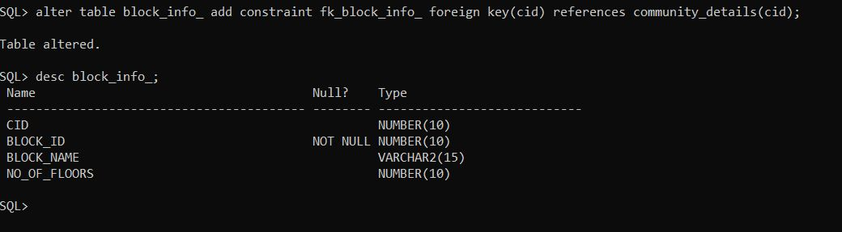

### 3)

create table water\_corperation\_(

block\_id number(10),

foreign key(block\_id) references block\_info\_(block\_id),

w\_id number(10) primary key,

no\_of\_lt number(10),

amount\_spent number(10));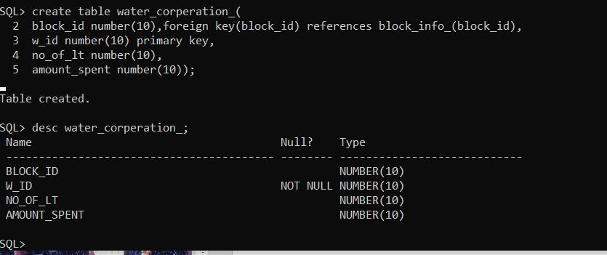

4)

create table parking\_(

cid number(10), foreign key(cid) references community\_details(cid),

parking\_id number(10) primary key ,

no\_of\_allotment number(10));

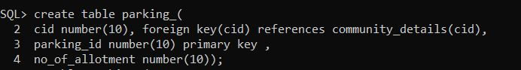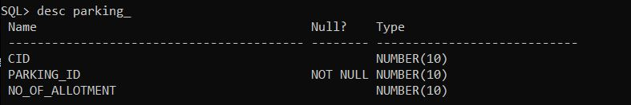

5)

create table sales\_(

block\_id number(10), foreign key(block\_id) references block\_info\_(block\_id),

s\_id number(10) primary key,

no\_of\_sales number(10));

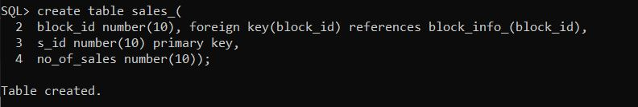

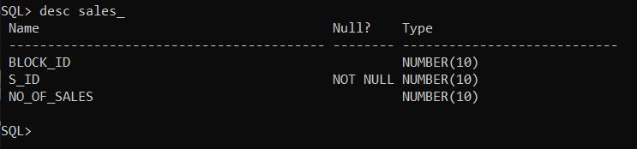

6)

create table purchases\_(

block\_id number(10),foreign key(block\_id) references block\_info\_(block\_id),

p\_id number(10) primary key,

no\_of\_purchases number(10))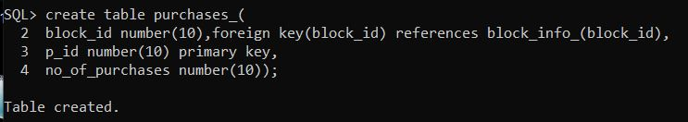

# 

# DML OPERATIONS:

## Inserting values into community\_details table

insert into community\_details values(&cid,’&cname’,&no\_of\_blocks,’&caddress’);

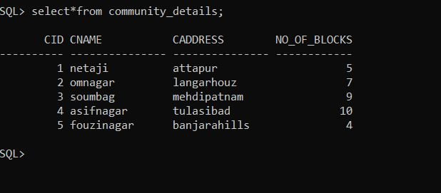

## Inserting values into block\_info\_ table

insert into block\_info\_ values(&cid,&block\_id'&block\_name',&no\_of\_blocks);

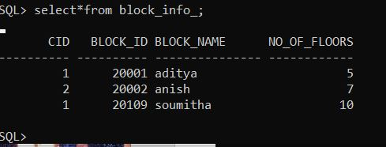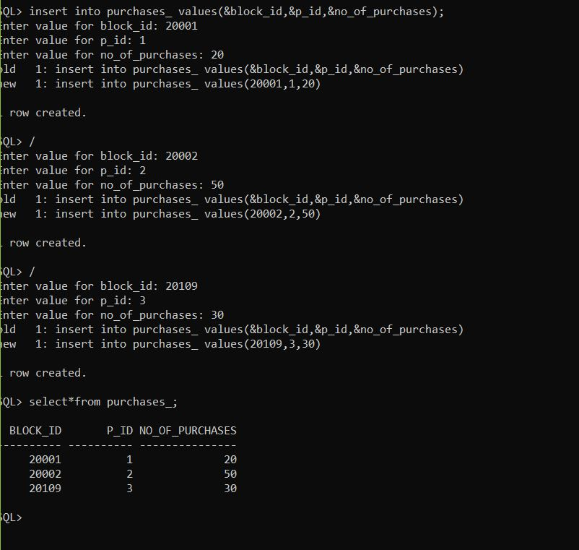

## Inserting values into water\_corperation\_ table

insert into water\_corperation values(&block\_id, &w\_id &amount\_spend,&number\_of\_lt);

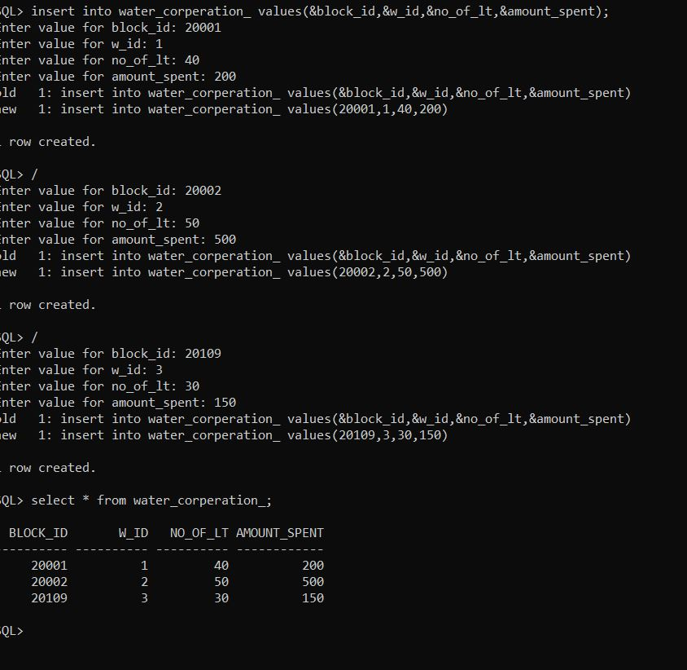

## 4)Inserting values into parking table

insert into parking values(&parking\_id,&block\_id ,’&vehicle’,&no\_of\_allotment);

## parking_ table

## 5)Inserting values into sales\_ table

insert into sales values(&s\_id,&block\_id ,&no\_of\_sales);

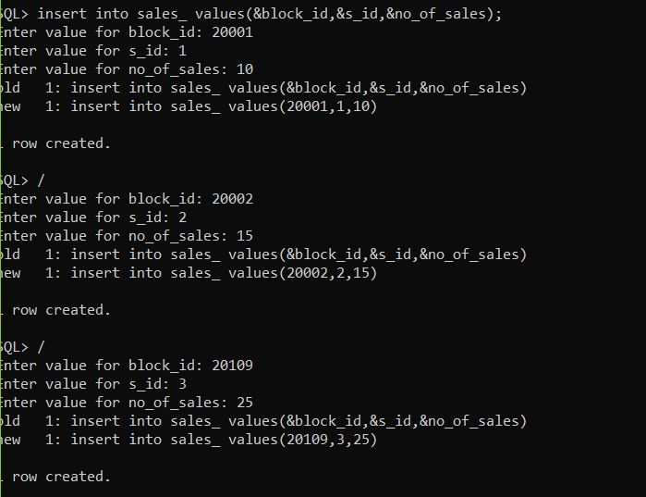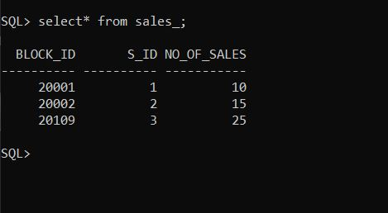

## 6) Inserting values into purchases table

insert into purchases values(&block\_id &p\_id,&no\_of\_purchases);

## 

**Front end programs and its connectivity**

Java Database Connectivity (JDBC) is an application programming interface (API) for the programming language Java, which defines how a client may access a database. It is a Java-based data access technology used for Java database connectivity. It is part of the Java Standard Edition platform, from Oracle Corporation. It provides methods to query and update data in a database and is oriented towards relational databases.

The connection to the database can be performed using Java programming (JDBC API) as:

**package** micro;

**import** java.sql.Connection;

**import** java.sql.DriverManager;

**import** javax.swing.JOptionPane;

**import** java.sql.\*;

**public** **class** SqlConnector {

Connection con=**null**;

**public** **static** Connection db() {

**try**{

Class.*forName*("oracle.jdbc.OracleDriver");

Connection con=DriverManager.*getConnection*("jdbc:oracle:thin:@localhost:1521:xe","soumitha","vasavi");

JOptionPane.*showMessageDialog*(**null**, "success");

**return** con;

}**catch**(Exception e){ System.***out***.println(e);

**return** **null**;}

}

**public** **static** **void** main(String args[]) {

*db*();

}

**MAIN METHOD:**

public class Main {

public static void main(String[] args) {

new PortalUI(); } }

**PortalUI:**

import java.awt.\*;

import javax.swing.\*;

import java.awt.Color;

import java.awt.FlowLayout;

import java.awt.Font;

import java.awt.GridLayout;

import java.awt.Label;

import java.awt.event.WindowAdapter;

import java.awt.event.WindowEvent;

import javax.swing.JFrame;

import javax.swing.JLabel;

import javax.swing.JMenu;

import javax.swing.JMenuBar;

import javax.swing.JMenuItem;

import javax.swing.JOptionPane;

import javax.swing.JPanel;

**PROJECT DETAILS:**

Application window:

package micro;

import java.awt.EventQueue;

import javax.swing.JFrame;

import javax.swing.JButton;

import java.awt.BorderLayout;

import java.awt.event.ActionListener;

import java.awt.event.ActionEvent;

import java.awt.Color;

import java.awt.Font;

import javax.swing.JTextArea;

import javax.swing.JTextField;

public class Sample {

private JFrame frame;

private JTextField txtSouniGatedCommunity;

/\*\*

\* Launch the application.

\*/

public static void main(String[] args) {

EventQueue.invokeLater(new Runnable() {

public void run() {

try {

Sample window = new Sample();

window.frame.setVisible(true);

} catch (Exception e) {

e.printStackTrace();

}

}

});

}

/\*\*

\* Create the application.

\*/

public Sample() {

initialize();

}

/\*\*

\* Initialize the contents of the frame.

\*/

private void initialize() {

frame = new JFrame();

frame.setBounds(150,200,763,548);

frame.setDefaultCloseOperation(JFrame.EXIT\_ON\_CLOSE);

frame.getContentPane().setLayout(null);

JButton btnNewButton = new JButton("water tracking");

btnNewButton.setBackground(Color.CYAN);

btnNewButton.setFont(new Font("Tahoma", Font.BOLD, 20));

btnNewButton.addActionListener(new ActionListener() {

public void actionPerformed(ActionEvent e) {

}

});

btnNewButton.setBounds(95, 157, 173, 129);

frame.getContentPane().add(btnNewButton);

JButton btnNewButton\_1 = new JButton(" sales and purchases");

btnNewButton\_1.setBackground(Color.PINK);

btnNewButton\_1.setFont(new Font("Tahoma", Font.BOLD, 19));

btnNewButton\_1.addActionListener(new ActionListener() {

public void actionPerformed(ActionEvent e) {

}

});

btnNewButton\_1.setBounds(446, 157, 155, 128);

frame.getContentPane().add(btnNewButton\_1);

JButton btnNewButton\_2 = new JButton("parking");

btnNewButton\_2.setBackground(Color.YELLOW);

btnNewButton\_2.setFont(new Font("Tahoma", Font.BOLD, 25));

btnNewButton\_2.addActionListener(new ActionListener() {

public void actionPerformed(ActionEvent e) {

}

});

btnNewButton\_2.setBounds(95, 341, 179, 129);

frame.getContentPane().add(btnNewButton\_2);

txtSouniGatedCommunity = new JTextField();

txtSouniGatedCommunity.setFont(new Font("Tahoma", Font.BOLD, 35));

txtSouniGatedCommunity.setText("SOUNI GATED COMMUNITY");

txtSouniGatedCommunity.setBounds(118, 30, 504, 66);

frame.getContentPane().add(txtSouniGatedCommunity);

txtSouniGatedCommunity.setColumns(10);

}

}

**Water track:**

package micro;

import java.awt.BorderLayout;

import java.awt.EventQueue;

import javax.swing.JFrame;

import javax.swing.JPanel;

import javax.swing.border.EmptyBorder;

import javax.swing.JButton;

import javax.swing.JTextPane;

import javax.swing.JLabel;

import javax.swing.JTextField;

import java.awt.event.ActionListener;

import java.awt.event.ActionEvent;

import java.awt.Font;

import java.awt.Color;

import javax.swing.JComboBox;

public class Sample2 extends JFrame {

private JPanel contentPane;

private JTextField textField;

private JTextField textField\_1;

private JTextField textField\_2;

/\*\*

\* Launch the application.

\*/

public static void main(String[] args) {

EventQueue.invokeLater(new Runnable() {

public void run() {

try {

Sample2 frame = new Sample2();

frame.setVisible(true);

} catch (Exception e) {

e.printStackTrace();

}

}

});

}

public void loaddetails(){

try{

Projectid = new Choice();

Projectid.removeAll();

Connection con1 = DriverManager.getConnection("jdbc:oracle:thin:@localhost:1521:xe", "anish", "vasavi");

Statement st1 = con1.createStatement();

ResultSet rs1 = st1.executeQuery("select \* from parking");

while(rs1.next())

{ Projectid.add(rs1.getString("bid"));

} }

catch(SQLException e) {

displaySQLErrors(e);

} }

public void loadproject(){

try{

ProjectList = new List();

ProjectList.removeAll();

Connection con2 = DriverManager.getConnection("jdbc:oracle:thin:@localhost:1521:xe", "anish", "vasavi");

Statement st2 = con2.createStatement();

ResultSet rs2 = st2.executeQuery("select \* from water\_track");

while(rs2.next()) {

ProjectList.add(rs2.getString("water\_used")); } }

catch(SQLException e) {

displaySQLErrors(e);

} }

/\*\*

\* Create the frame.

\*/

public Sample2() {

setDefaultCloseOperation(JFrame.EXIT\_ON\_CLOSE);

setBounds(100, 100, 839, 610);

contentPane = new JPanel();

contentPane.setBorder(new EmptyBorder(5, 5, 5, 5));

setContentPane(contentPane);

contentPane.setLayout(null);

JButton btnNewButton\_2 = new JButton("DISPLAY");

btnNewButton\_2.setBackground(Color.RED);

btnNewButton\_2.setFont(new Font("Tahoma", Font.BOLD, 22));

btnNewButton\_2.addActionListener(new ActionListener() {

public void actionPerformed(ActionEvent e) {

}

});

btnNewButton\_2.setBounds(371, 348, 172, 54);

contentPane.add(btnNewButton\_2);

JLabel lblNewLabel = new JLabel("block id");

lblNewLabel.setBackground(Color.GRAY);

lblNewLabel.setFont(new Font("Tahoma", Font.PLAIN, 20));

lblNewLabel.setBounds(57, 133, 120, 43);

contentPane.add(lblNewLabel);

JLabel lblNewLabel\_1 = new JLabel("block name");

lblNewLabel\_1.setBackground(Color.GRAY);

lblNewLabel\_1.setFont(new Font("Tahoma", Font.PLAIN, 20));

lblNewLabel\_1.setBounds(57, 246, 120, 43);

contentPane.add(lblNewLabel\_1);

textField = new JTextField();

textField.setBounds(277, 132, 193, 54);

contentPane.add(textField);

textField.setColumns(10);

textField\_1 = new JTextField();

textField\_1.setBounds(277, 246, 193, 56);

contentPane.add(textField\_1);

textField\_1.setColumns(10);

JLabel lblNewLabel\_2 = new JLabel("the amount of water used per day is");

lblNewLabel\_2.setFont(new Font("Tahoma", Font.BOLD, 20));

lblNewLabel\_2.setBounds(71, 471, 374, 43);

contentPane.add(lblNewLabel\_2);

JLabel lblNewLabel\_3 = new JLabel("litres ");

lblNewLabel\_3.setFont(new Font("Tahoma", Font.BOLD, 20));

lblNewLabel\_3.setBounds(561, 484, 68, 16);

contentPane.add(lblNewLabel\_3);

textField\_2 = new JTextField();

textField\_2.setBounds(455, 478, 96, 28);

contentPane.add(textField\_2);

textField\_2.setColumns(10);

JButton btnNewButton = new JButton("EXIT");

btnNewButton.setFont(new Font("Tahoma", Font.BOLD, 20));

btnNewButton.setBounds(609, 348, 160, 54);

contentPane.add(btnNewButton);

JLabel lblNewLabel\_4 = new JLabel("WATER TRACK");

lblNewLabel\_4.setFont(new Font("Tahoma", Font.BOLD, 30));

lblNewLabel\_4.setBounds(243, 31, 287, 43);

contentPane.add(lblNewLabel\_4);

}

}

**Sales and purchases:**

package micro;

import java.awt.BorderLayout;

import java.awt.EventQueue;

import javax.swing.JFrame;

import javax.swing.JPanel;

import javax.swing.border.EmptyBorder;

import javax.swing.JLabel;

import java.awt.Font;

import javax.swing.JTextField;

import javax.swing.JButton;

import java.awt.event.ActionListener;

import java.awt.event.ActionEvent;

public class SalePurchase extends JFrame {

private JPanel contentPane;

private JTextField textField;

private JTextField textField\_1;

private JTextField textField\_2;

private JTextField textField\_3;

private JTextField textField\_4;

/\*\*

\* Launch the application.

\*/

public static void main(String[] args) {

EventQueue.invokeLater(new Runnable() {

public void run() {

try {

SalePurchase frame = new SalePurchase();

frame.setVisible(true);

} catch (Exception e) {

e.printStackTrace();

}

}

});

}

public void loaddetails(){

try{

Projectid = new Choice();

Projectid.removeAll();

Connection con1 = DriverManager.getConnection("jdbc:oracle:thin:@localhost:1521:xe", "anish", "vasavi");

Statement st1 = con1.createStatement();

ResultSet rs1 = st1.executeQuery("select \* from sale\_purchase");

while(rs1.next())

{ Projectid.add(rs1.getString("saleused"));

} }

catch(SQLException e) {

displaySQLErrors(e);

} }

public void loadproject(){

try{

ProjectList = new List();

ProjectList.removeAll();

Connection con2 = DriverManager.getConnection("jdbc:oracle:thin:@localhost:1521:xe", "anish", "vasavi");

Statement st2 = con2.createStatement();

ResultSet rs2 = st2.executeQuery("select \* from sale\_purchase");

while(rs2.next()) {

ProjectList.add(rs2.getString("sales")); } }

catch(SQLException e) {

displaySQLErrors(e);

} }

/\*\*

\* Create the frame.

\*/

public SalePurchase() {

setDefaultCloseOperation(JFrame.EXIT\_ON\_CLOSE);

setBounds(100, 100, 844, 611);

contentPane = new JPanel();

contentPane.setBorder(new EmptyBorder(5, 5, 5, 5));

setContentPane(contentPane);

contentPane.setLayout(null);

JLabel lblNewLabel = new JLabel("block id");

lblNewLabel.setFont(new Font("Tahoma", Font.PLAIN, 20));

lblNewLabel.setBounds(60, 115, 133, 34);

contentPane.add(lblNewLabel);

JLabel lblNewLabel\_1 = new JLabel("block name");

lblNewLabel\_1.setFont(new Font("Tahoma", Font.PLAIN, 20));

lblNewLabel\_1.setBounds(56, 209, 102, 25);

contentPane.add(lblNewLabel\_1);

textField = new JTextField();

textField.setBounds(247, 115, 151, 43);

contentPane.add(textField);

textField.setColumns(10);

textField\_1 = new JTextField();

textField\_1.setBounds(247, 204, 151, 43);

contentPane.add(textField\_1);

textField\_1.setColumns(10);

JButton btnNewButton = new JButton("DISPLAY");

btnNewButton.setFont(new Font("Tahoma", Font.BOLD, 20));

btnNewButton.setBounds(381, 302, 133, 49);

contentPane.add(btnNewButton);

JButton btnNewButton\_1 = new JButton("EXIT");

btnNewButton\_1.setFont(new Font("Tahoma", Font.BOLD, 20));

btnNewButton\_1.addActionListener(new ActionListener() {

public void actionPerformed(ActionEvent e) {

}

});

btnNewButton\_1.setBounds(575, 302, 133, 49);

contentPane.add(btnNewButton\_1);

JLabel lblNewLabel\_2 = new JLabel("no. of flats");

lblNewLabel\_2.setFont(new Font("Tahoma", Font.PLAIN, 20));

lblNewLabel\_2.setBounds(60, 406, 192, 34);

contentPane.add(lblNewLabel\_2);

textField\_2 = new JTextField();

textField\_2.setBounds(247, 411, 140, 34);

contentPane.add(textField\_2);

textField\_2.setColumns(10);

JLabel lblNewLabel\_3 = new JLabel("on sale");

lblNewLabel\_3.setFont(new Font("Tahoma", Font.PLAIN, 20));

lblNewLabel\_3.setBounds(60, 480, 109, 25);

contentPane.add(lblNewLabel\_3);

textField\_3 = new JTextField();

textField\_3.setBounds(251, 487, 140, 34);

contentPane.add(textField\_3);

textField\_3.setColumns(10);

JLabel lblNewLabel\_4 = new JLabel("purchased");

lblNewLabel\_4.setFont(new Font("Tahoma", Font.PLAIN, 20));

lblNewLabel\_4.setBounds(432, 477, 117, 31);

contentPane.add(lblNewLabel\_4);

textField\_4 = new JTextField();

textField\_4.setBounds(598, 487, 118, 34);

contentPane.add(textField\_4);

textField\_4.setColumns(10);

JLabel lblNewLabel\_5 = new JLabel("SALES AND PURCHASES");

lblNewLabel\_5.setFont(new Font("Tahoma", Font.BOLD, 30));

lblNewLabel\_5.setBounds(206, 24, 434, 43);

contentPane.add(lblNewLabel\_5);

}

}

**Percentage of parking:**

package micro;

import java.awt.BorderLayout;

import java.awt.EventQueue;

import javax.swing.JFrame;

import javax.swing.JPanel;

import javax.swing.border.EmptyBorder;

import javax.swing.JLabel;

import java.awt.Font;

import javax.swing.JTextField;

import javax.swing.JButton;

import java.awt.event.ActionListener;

import java.awt.event.ActionEvent;

public class Parking extends JFrame {

private JPanel contentPane;

private JTextField textField;

private JTextField textField\_1;

private JTextField textField\_2;

/\*\*

\* Launch the application.

\*/

public static void main(String[] args) {

EventQueue.invokeLater(new Runnable() {

public void run() {

try {

Parking frame = new Parking();

frame.setVisible(true);

} catch (Exception e) {

e.printStackTrace();

}

}

};

}

public void loaddetails(){

try{

Projectid = new Choice();

Projectid.removeAll();

Connection con1 = DriverManager.getConnection("jdbc:oracle:thin:@localhost:1521:xe", "anish", "vasavi");

Statement st1 = con1.createStatement();

ResultSet rs1 = st1.executeQuery("select \* from parking");

while(rs1.next())

{ Projectid.add(rs1.getString("bid"));

} }

catch(SQLException e) {

displaySQLErrors(e);

} }

public void loadproject(){

try{

ProjectList = new List();

ProjectList.removeAll();

Connection con2 = DriverManager.getConnection("jdbc:oracle:thin:@localhost:1521:xe", "anish", "vasavi");

Statement st2 = con2.createStatement();

ResultSet rs2 = st2.executeQuery("select \* from parking");

while(rs2.next()) {

ProjectList.add(rs2.getString("bid")); } }

catch(SQLException e) {

displaySQLErrors(e);

} }

/\*\*

\* Create the frame.

\*/

public Parking() {

setDefaultCloseOperation(JFrame.EXIT\_ON\_CLOSE);

setBounds(100, 100, 819, 594);

contentPane = new JPanel();

contentPane.setBorder(new EmptyBorder(5, 5, 5, 5));

setContentPane(contentPane);

contentPane.setLayout(null);

JLabel lblNewLabel = new JLabel("block id");

lblNewLabel.setFont(new Font("Tahoma", Font.PLAIN, 20));

lblNewLabel.setBounds(56, 128, 128, 33);

contentPane.add(lblNewLabel);

JLabel lblNewLabel\_1 = new JLabel("block name");

lblNewLabel\_1.setFont(new Font("Tahoma", Font.PLAIN, 20));

lblNewLabel\_1.setBounds(56, 219, 138, 33);

contentPane.add(lblNewLabel\_1);

textField = new JTextField();

textField.setBounds(232, 128, 228, 44);

contentPane.add(textField);

textField.setColumns(10);

textField\_1 = new JTextField();

textField\_1.setBounds(232, 230, 228, 44);

contentPane.add(textField\_1);

textField\_1.setColumns(10);

JButton btnNewButton = new JButton("DISPLAY");

btnNewButton.setFont(new Font("Tahoma", Font.BOLD, 20));

btnNewButton.setBounds(300, 332, 160, 44);

contentPane.add(btnNewButton);

JButton btnNewButton\_1 = new JButton("EXIT");

btnNewButton\_1.addActionListener(new ActionListener() {

public void actionPerformed(ActionEvent e) {

}

});

btnNewButton\_1.setFont(new Font("Tahoma", Font.BOLD, 20));

btnNewButton\_1.setBounds(530, 332, 115, 44);

contentPane.add(btnNewButton\_1);

JLabel lblNewLabel\_2 = new JLabel("parking percentage is ");

lblNewLabel\_2.setFont(new Font("Tahoma", Font.PLAIN, 20));

lblNewLabel\_2.setBounds(56, 436, 243, 25);

contentPane.add(lblNewLabel\_2);

textField\_2 = new JTextField();

textField\_2.setBounds(300, 432, 138, 44);

contentPane.add(textField\_2);

textField\_2.setColumns(10);

JLabel lblNewLabel\_3 = new JLabel("PARKING PERCENTAGE");

lblNewLabel\_3.setFont(new Font("Tahoma", Font.BOLD, 30));

lblNewLabel\_3.setBounds(192, 43, 425, 33);

contentPane.add(lblNewLabel\_3);

}

}

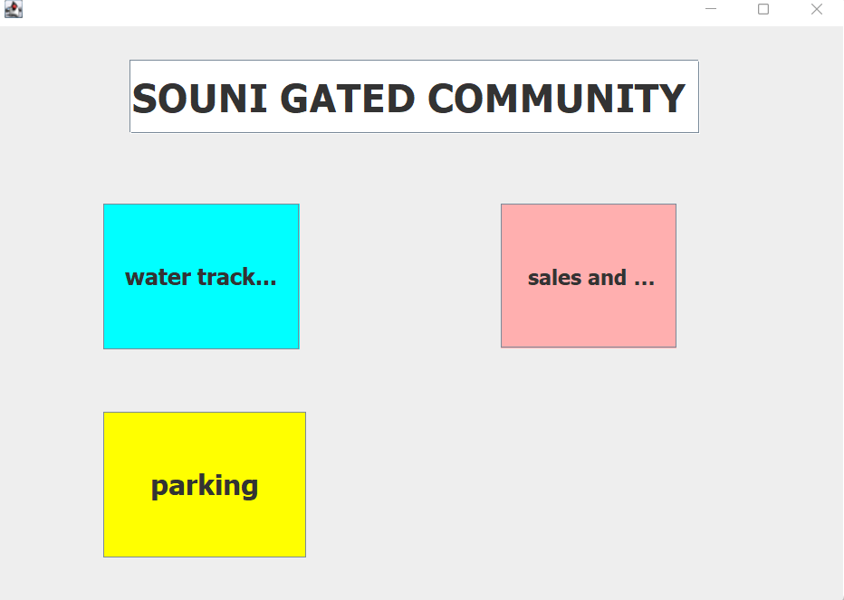

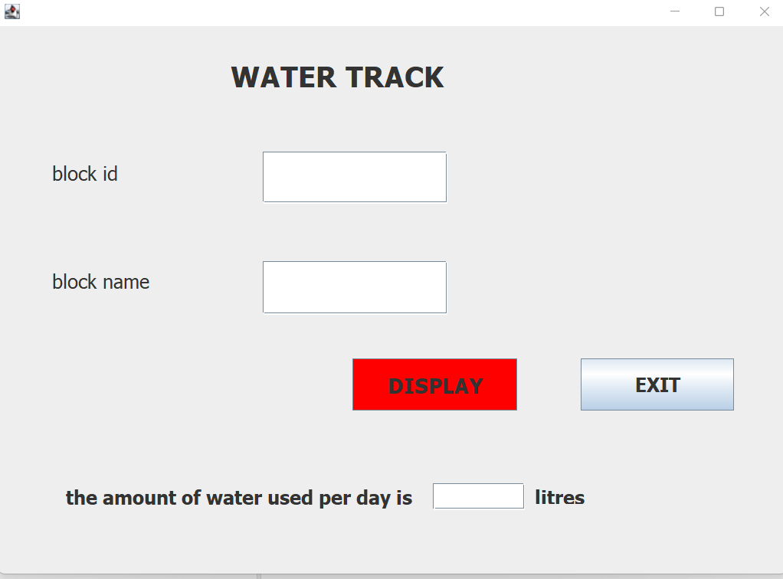

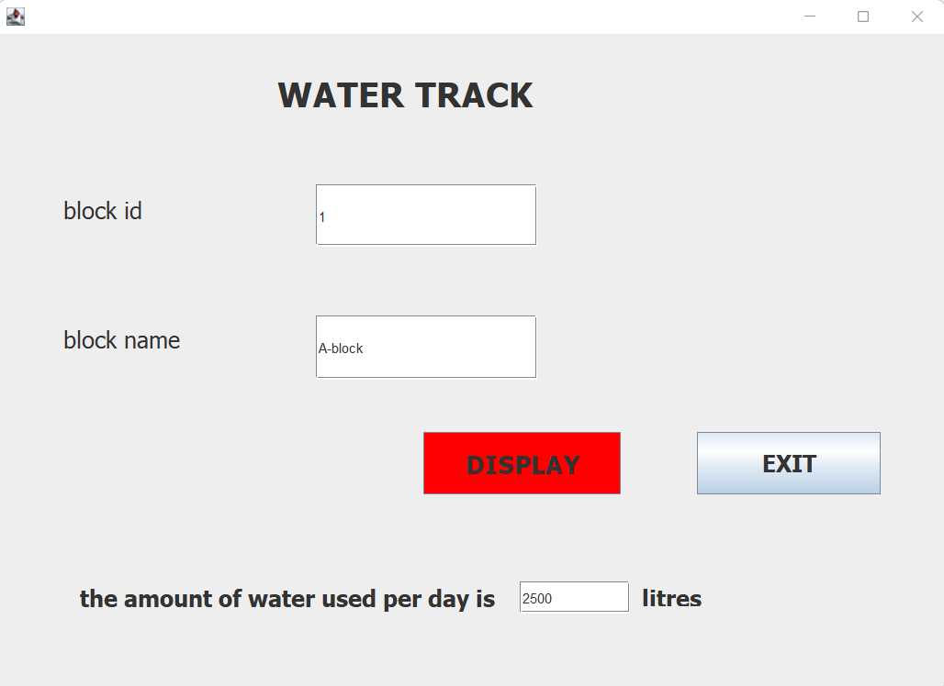

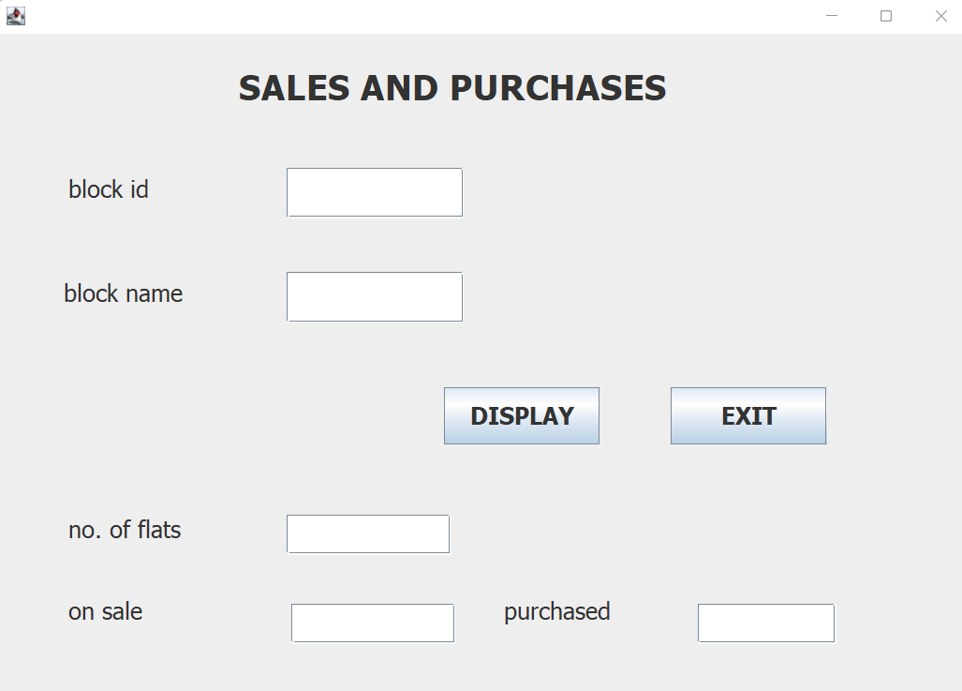

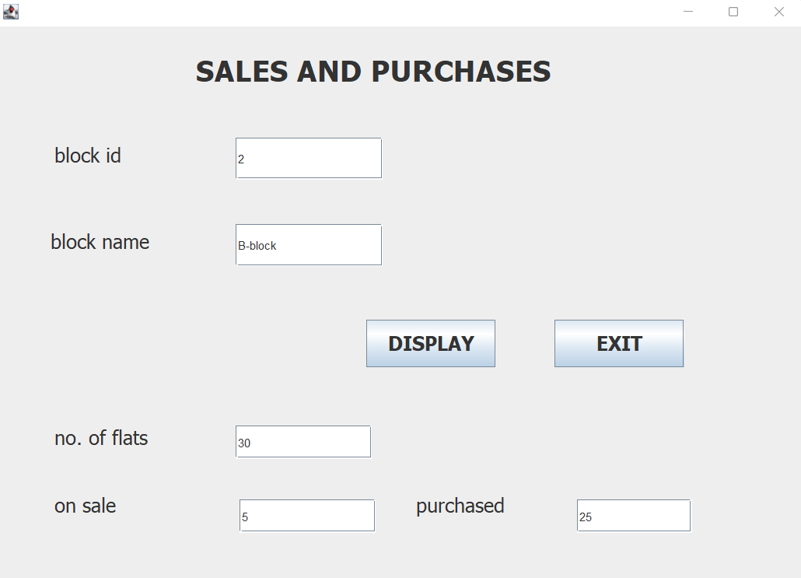

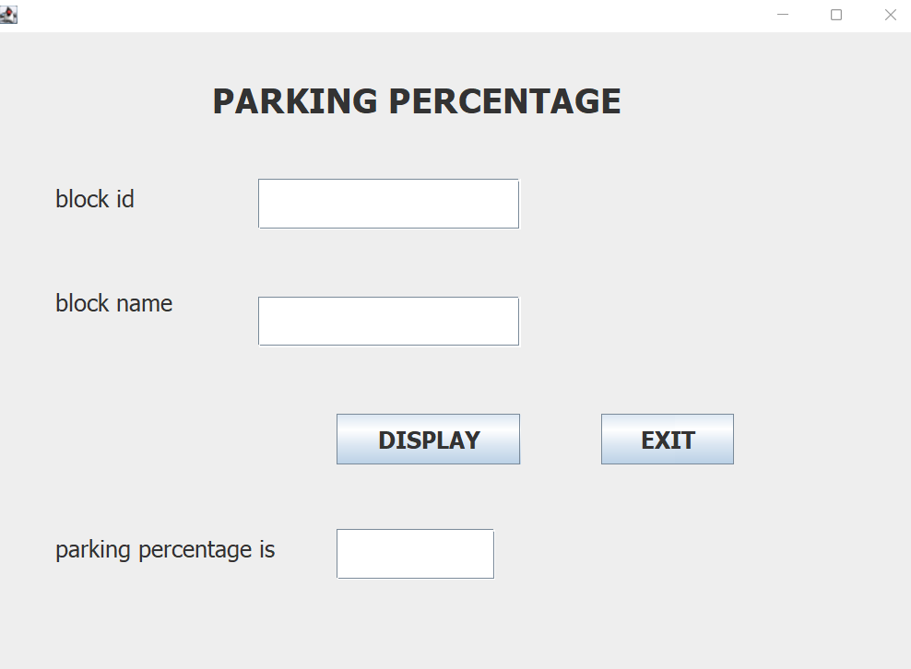

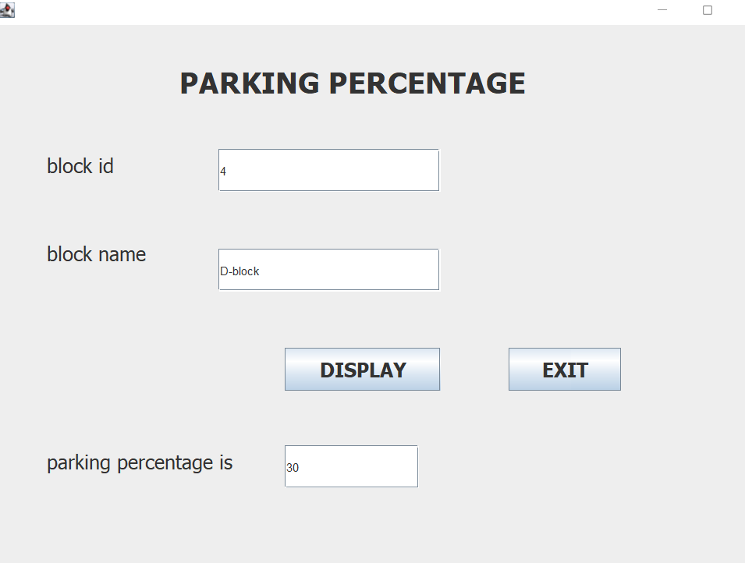

**DISCUSSION AND FUTURE WORK**

So far this project helps us to track every detail of a gated community system.it tracks water usage,no of flats on sale and purchased and the percentage of parking allotted to each block.we further tried to add details of new block and and some more features.

**REFERENCES:**

1. Abraham Silberschatz, Henry F Korth, S. Sudarshan, Database System Concepts, 6th Edition, McGraw-Hill International Edition, 2010. 2. https://docs.oracle.com/cd/E11882\_01/server.112/e40540/intro.htm#CNCPT001 3. https://docs.oracle.com/javase/8/docs/